**Adding new Adapters to ESB Itinerary**

https://www.biztalk-server-tutorial.com/2014/12/18/part-4-adding-new-adapters-to-esb-itinerary/

Default itinerary comes with few Adapters as below.

[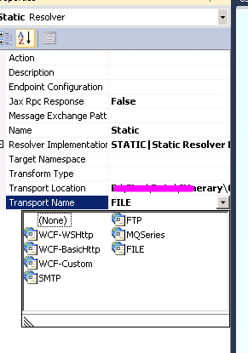](http://masterbiztalk.wpengine.com/wp-content/uploads/2014/12/110.png)

What if you want a new Adapter (for example HTTP, WCF-NetTCP etc.)? Solution is to create ESB Adapter Provider.  
1. Create a simple class library and add a reference to add reference to “Microsoft.Practices.ESB.Adapter” in BizTalk ESB Toolkit Installation Folder\Bin

[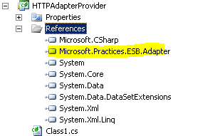](http://masterbiztalk.wpengine.com/wp-content/uploads/2014/12/23.png)

1. Create a class extending the “BaseAdapterProvider” as shown below.

using Microsoft.Practices.ESB.Adapter;

using System;

using System.Collections.Generic;

using System.Linq;

using System.Text;

using System.Threading.Tasks;

namespace Mobiletec.Biztalk.AdaptersPoc.Http

{

public class HttpAdapterProvider : BaseAdapterProvider

{

public override string AdapterName

{

get

{

return "HTTP";

}

}

}

}

[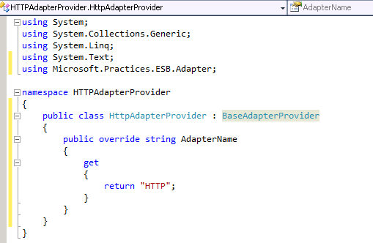](http://masterbiztalk.wpengine.com/wp-content/uploads/2014/12/32.png)

3. Sign the assembly, GAC the DLL.  
4. Open esb.config file in the BizTalk ESB Toolkit Installation Folder and under “adapterProviders” add new configuration detail like below

[4](http://masterbiztalk.wpengine.com/wp-content/uploads/2014/12/42.png)

5. Restart Visual Studio. Now you should be able to see the new Adapter.

[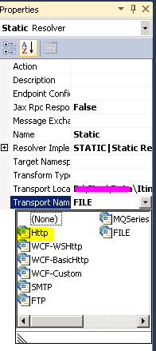](http://masterbiztalk.wpengine.com/wp-content/uploads/2014/12/52.png)

In the same way you can extend “WCFBaseAdapterProvider” and create WCF based Adapters like below.

namespace Mobiletec.Biztalk.AdaptersPoc.Http

{

public class HttpAdapterProvider : BaseAdapterProvider

{

public override string AdapterName

{

get

{

return "HTTP";

}

}

}

}

Como registrar en el Esb sección AdapterProviders

